Layout Pane
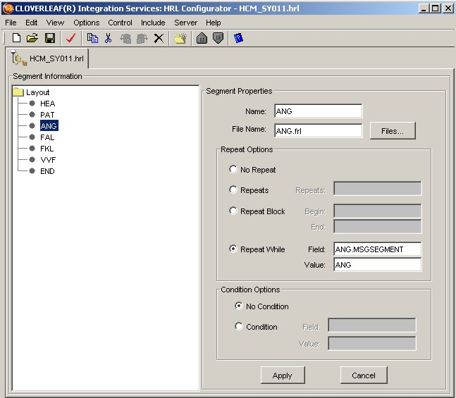
Title Bar
Menu Bar
Toolbar
Properties

Repeat Options Pane
Condition Options Pane

